BIG MOTHER IS
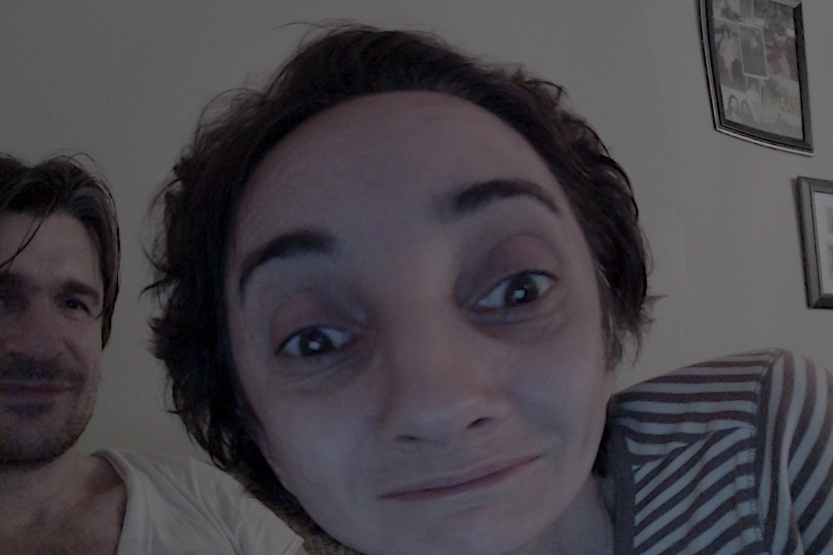
WATCHING YOU

